**Report for Simple Linear Regression Project / IE 5318 / Fall 2020**

**Due date:** Oct. 19, 2020

**Title**

**To predict the expected profit of a start-up firm.**

**Dataset reference**

https://www.kaggle.com/root64shivansh/profit-in-startup-of-a-company/notebooks?sortBy=dateRun&group=profile&pageSize=20&datasetId=457637

**Team members**

**Shekhar Madhav Khairnar (1001822833)**

**Jayant Vithalrao Madan (1001814817)**

**Section 1: Background and data description**

**Describe the problem (i.e. the background),**

Earning a profit is important to startups because it decides whether a company can secure financing from a bank, attract investors to fund its operations, and grow its business. Companies cannot remain in business without turning a profit. Startups are full of promise and excitement, but the flip side is, they’re also full of risk and uncertainty. There are a lot of great ideas out there that somehow never get off the ground, and, conversely, there are plenty of questionable ones that become massive successes.

So, the big picture is a puzzle: Look objectively at a list of successes and failures, and you'll be hard-pressed to pinpoint any one reason why one startup would succeed over another. That’s there are no one factors for profit and revenue, there are dozens.

**Yet, even those dozens may be whittled down to the most critical ones. Here they are:**

Research and Development spend - Increased market participation, cost management benefits, advancements in marketing abilities, and trend-matching these are all reasons companies invest in R&D. R&D can help a company stay ahead of market trends and keep the company relevant.

Administration - No business can succeed to any great degree without being properly organized. Doing administration makes your business properly organized. The performance of people in business administration and business management ensures that a company continues to work smoothly. without administration, The company’s goals would not be formed, and the implementation of goals would fail.

Marketing spends - Marketing is important because it helps you sell your products or services. The bottom line of any business is to make money and marketing is an essential channel to reach that end goal. Experts explained that without marketing many businesses wouldn't exist because marketing is ultimately what drives sales.

State - The importance of location in business success cannot be understated. The location of business positions it not only to attract a customer base but also to attract the right sort of talent to make the business a success. A business’s location also helps it create a brand and image since there are always parts of a city that carry a reputation.

**The variables**

The dataset consists of the following attributes examined

* The response variable (y)

1. Profit

* Predictor variables (x)

1. Research and Development spend
2. Administration
3. Marketing spends
4. State

**Discuss why modeling this data set would be meaningful.**

To be successful and remain in business profit is important and necessary for a company to survive and remain attractive to investors and analysts. Profit is, of course, critical to a company's existence.

**Present and discuss scatter plots of the response variable vs. each of the predictor variables.**

**1 - Profit vs research and development**



**2 - Profit vs administration**

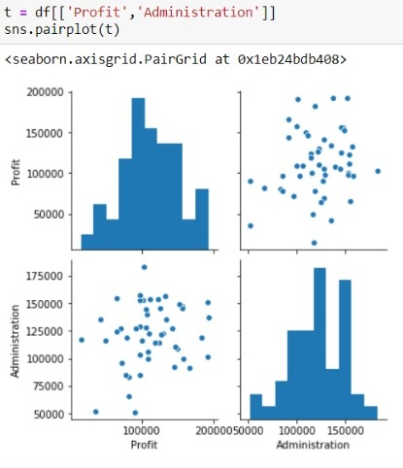

**3 - Profit vs marketing spends**



**Select one predictor variable for your project and explain your choice.**

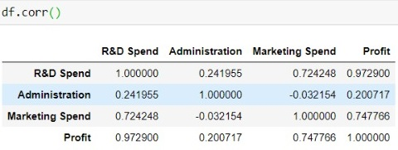



**From the above co-relation, heatmap and chart one can easily examine that the correlation between the response variable (“Profit”) and predictor variable (“Research and development spend”) has the highest correlation coefficient of 0.972 i.e 97.2%. Hence, we recognized that this should be the most important variable affecting the decision for functioning and initialization of a start-up.**